Rossmoyne Senior High School

Semester One Examination, 2014

Question/Answer Booklet

MATHEMATICS SPECIALIST 3C
SOLUTIONS

Section Two:

Calculator-assumed

Student Number: In figures

In words

Your name

Time allowed for this section
Reading time before commencing work: ten minutes
Working time for this section: one hundred minutes

Materials required/recommended for this section

To be provided by the supervisor
This Question/Answer Booklet
Formula Sheet (retained from Section One)

To be provided by the candidate
Standard items: pens, pencils, pencil sharpener, eraser, correction fluid/tape, ruler, highlighters

Special items: drawing instruments, templates, notes on two unfolded sheets of A4 paper, and up to three calculators satisfying the conditions set by the Curriculum Council for this examination.

Important note to candidates

No other items may be used in this section of the examination. It is your responsibility to ensure that you do not have any unauthorised notes or other items of a non-personal nature in the examination room. If you have any unauthorised material with you, hand it to the supervisor before reading any further.

Structure of this paper

Section | Number of questions available | Number of questions to be answered | Working time (minutes) | Marks available | Percentage of exam
Section One:  Calculator-free | 7 | 7 | 50 | 50 | 33⅓
Section Two:  Calculator-assumed | 13 | 13 | 100 | 100 | 66⅔
 |  |  | Total | 150 | 100

Instructions to candidates

- The rules for the conduct of Western Australian external examinations are detailed in the Year 12 Information Handbook 2013. Sitting this examination implies that you agree to abide by these rules.

- Write your answers in the spaces provided in this Question/Answer Booklet. Spare pages are included at the end of this booklet. They can be used for planning your responses and/or as additional space if required to continue an answer.
- Planning: If you use the spare pages for planning, indicate this clearly at the top of the page.
- Continuing an answer: If you need to use the space to continue an answer, indicate in the original answer space where the answer is continued, i.e. give the page number. Fill in the number of the question(s) that you are continuing to answer at the top of the page.

- Show all your working clearly. Your working should be in sufficient detail to allow your answers to be checked readily and for marks to be awarded for reasoning. Incorrect answers given without supporting reasoning cannot be allocated any marks. For any question or part question worth more than two marks, valid working or justification is required to receive full marks. If you repeat an answer to any question, ensure that you cancel the answer you do not wish to have marked.

- It is recommended that you do not use pencil, except in diagrams.

Section Two: Calculator-assumed (100 Marks)
This section has thirteen (13) questions. Answer all questions. Write your answers in the spaces provided.

Working time for this section is 100 minutes.

Question 8 (5 marks)
(a) Express the following in exact polar form 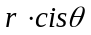:

(i) 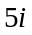 (1 mark)
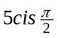

(ii) 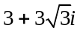 (1 mark)
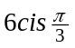

(b) Express the following in exact Cartesian form 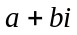:

(i) 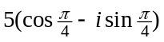 (1 mark)
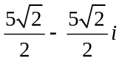

(ii) 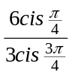 (1 mark)
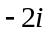

(iii) 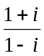 (1 mark)

Question 9 (8 marks)
Let 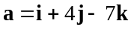 and 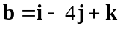.

(a) Calculate the angle between and , to the nearest degree. (2 marks)

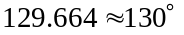

(b) Determine vector , parallel to the resultant of and and with a magnitude of 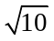.
(2 marks)
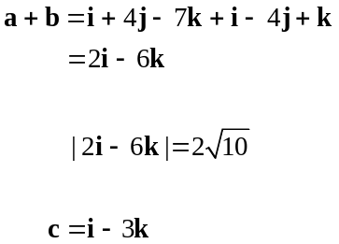

(c) Determine a unit vector , perpendicular to both and . (4 marks)

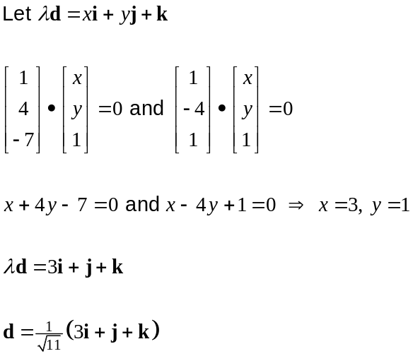

Question 10 (5 marks)
Let 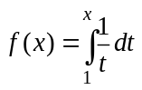, 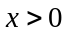.

(a) Write down a decimal approximation for 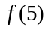, rounded to 2 decimal places. (2 marks)

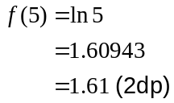

(b) Write down an exact value for 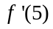. (2 marks)

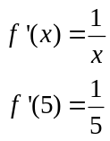

(c) Write down a simplified expression for . (1 mark)
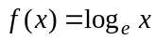

Question 11 (6 marks)
A curve is defined implicitly by 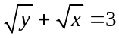.

(a) Determine an expression for 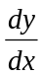. (1 mark)
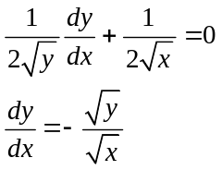

(b) Describe the gradient of the curve for 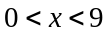

(i) as approaches 9. (1 mark)
Gradient becomes very small and negative, tending to 0. 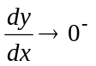.

(ii) as approaches 9. (1 mark)
Gradient becomes very large and negative. 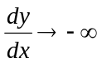.

(c) Determine the equation of the tangent to the curve when 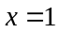. (3 marks)

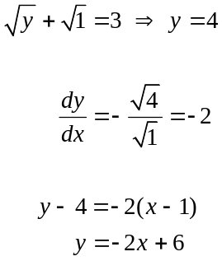

Question 12 (8 marks)
(a) On the Argand diagram below, sketch and label both of the following sets of points:

(i) 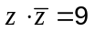 (2 marks)
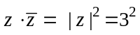

(ii) 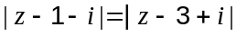 (3 marks)
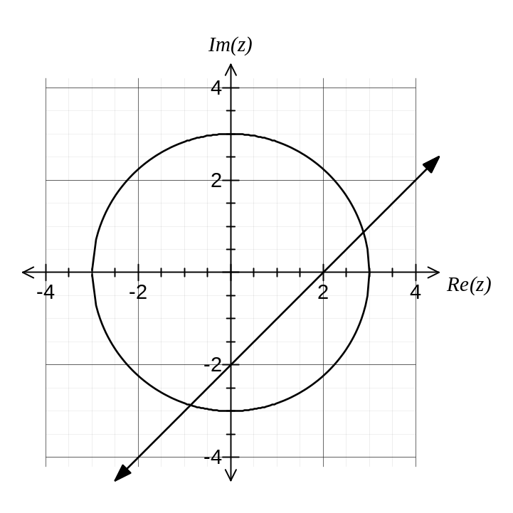

(b) Determine, to four decimal places, the largest possible argument, 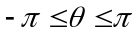, of the complex number that satisfies . (3 marks)
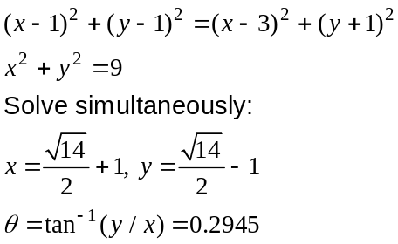

Question 13 (10 marks)
The Cartesian equation of a plane is 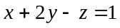.

(a) State a vector equation of this plane. (1 mark)

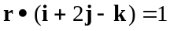

The parametric equations of line are 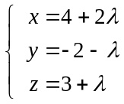.

(b) State a vector equation for line . (1 mark)

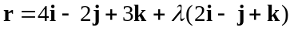

(c) Determine the position vector of , the point of intersection of line and the plane.
(4 marks)
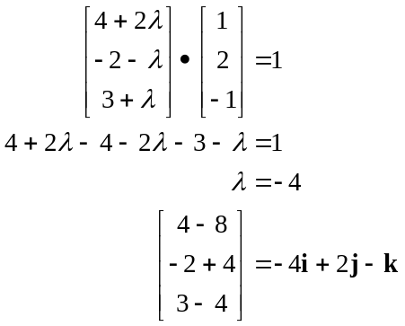

(d) The points and  both lie on line such that divides 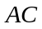 internally in the ratio 1:2. Determine the position vector of given that has position vector 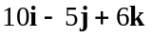.
(4 marks)
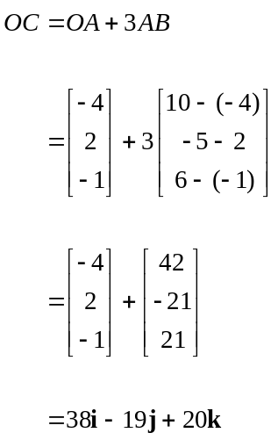

Question 14 (7 marks)
(a) Show that the gradient of the curve 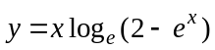 at the origin is 0. (3 marks)
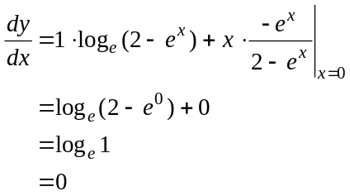

(b) The graphs of 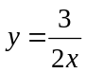, and are shown below.
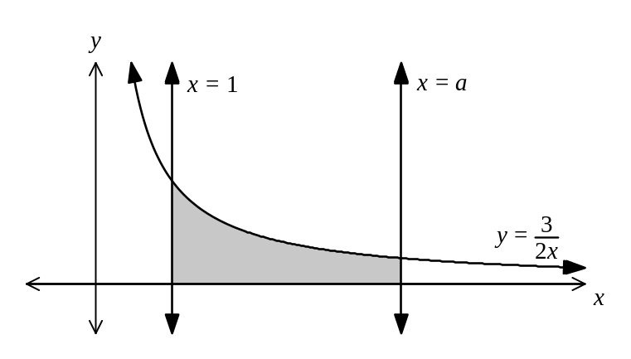
(i) Determine the exact value of , 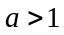, given that the shaded region has an area of 6 square units. (3 marks)
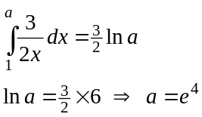

(ii) Determine the exact area between and the -axis from to 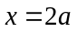.
(1 mark)
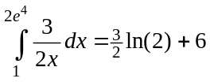

Question 15 (7 marks)
In the diagram of triangle 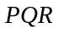 below, 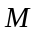 is the midpoint of side 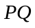, lies on the side 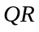 such that 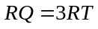 and 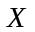 is the point of intersection of lines 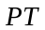 and 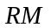 such that 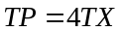.
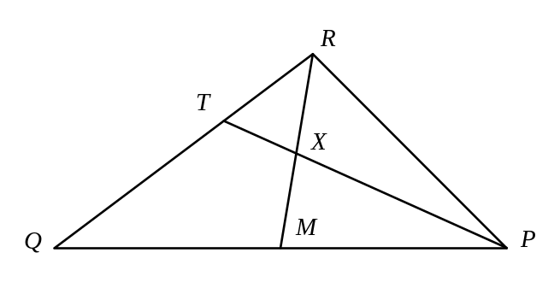
Let 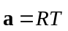 and 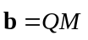.

(a) Express the following vectors in terms of and/or .

(i) 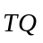 (1 mark)
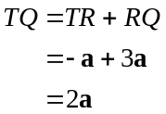

(ii) 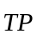 (1 mark)
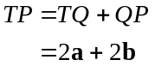

(b) Show that 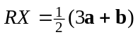. (2 marks)
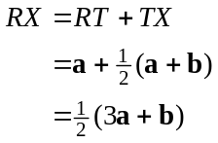

(c) Prove that bisects . (3 marks)

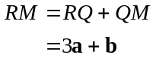
Since 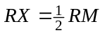 then must bisect .

Question 16 (8 marks)
(a) Use polar inequalities to describe the shaded region shown below. (2 marks)
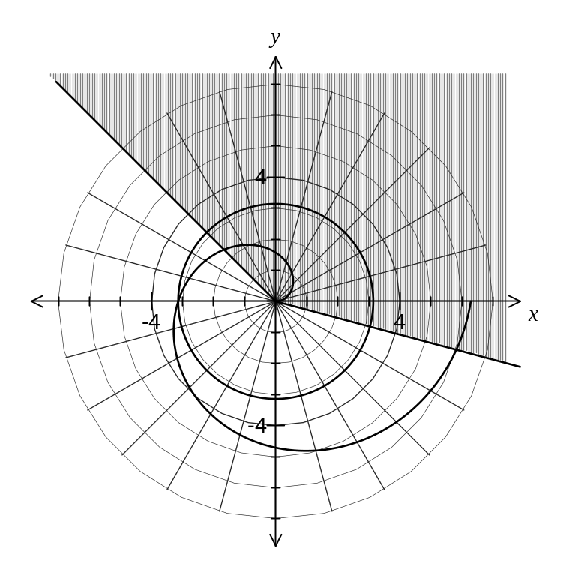
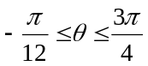
(b) Sketch the polar graph on the axes above. (1 mark)

(c) Sketch the polar graph 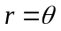 on the axes above. (2 marks)

(d) Show that the shortest distance from the point of intersection of and to the shaded region shown above is 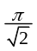. (3 marks)

Intersect at P, when 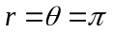.
Shortest distance is through P and perpendicular to 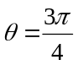.
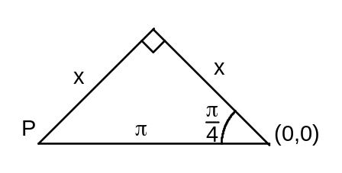
Using the sketch and Pythagoras' theorem: 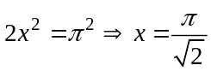

Question 17 (8 marks)
Let 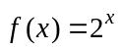 and 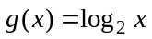.

(a) Sketch the graphs of 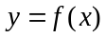 and 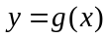 on the axes below. (2 marks)
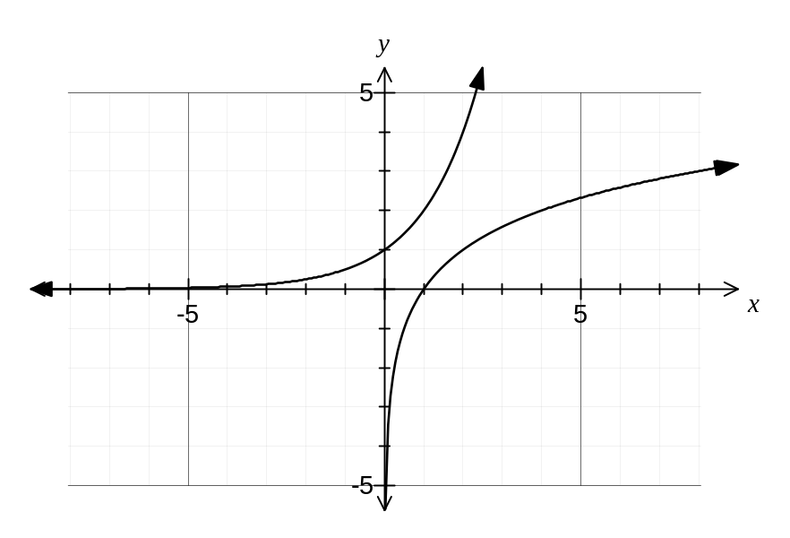
(b) Describe the relationship between the functions and 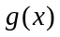. (1 mark)
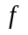 and are inverses of each other.

(c) Determine an expression for 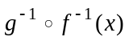, . (1 mark)
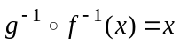

(d) Show that for , 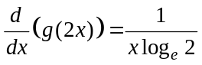. (2 marks)
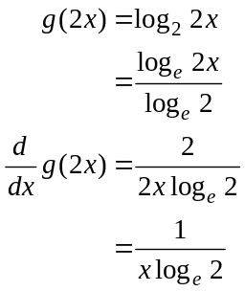

(e) If 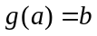 and 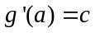, where , and are positive real numbers, determine an expression for 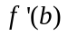. (2 marks)
Since is the inverse of , then 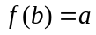 and so will be the reciprocal of the slope of when .
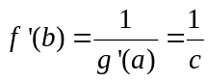

Question 18 (9 marks)
In this question you may assume that 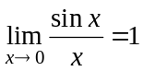 and the properties 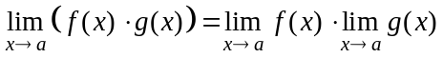 and 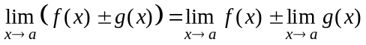.

(a) Continue to simplify the limit below, to establish that 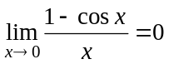. (3 marks)

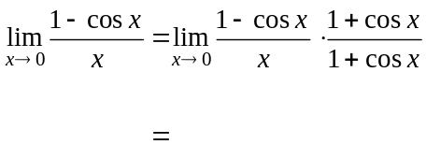
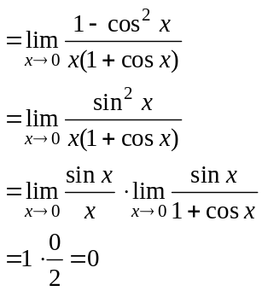

(b) If 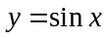, then from first principles, 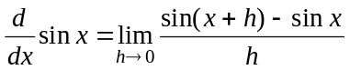. Continue to simplify this limit, to show that 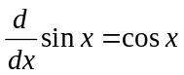. (3 marks)
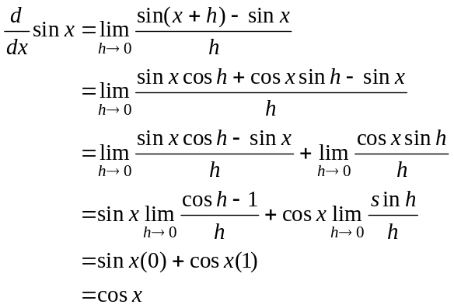

(c) Show that 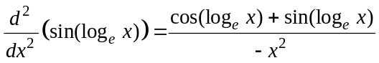. (3 marks)
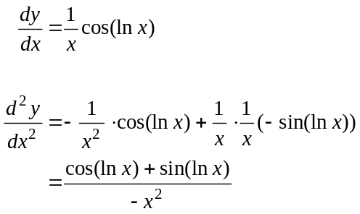

Question 19 (14 marks)
A right triangular prism 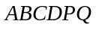 is shown (not to scale). All lengths are in metres.
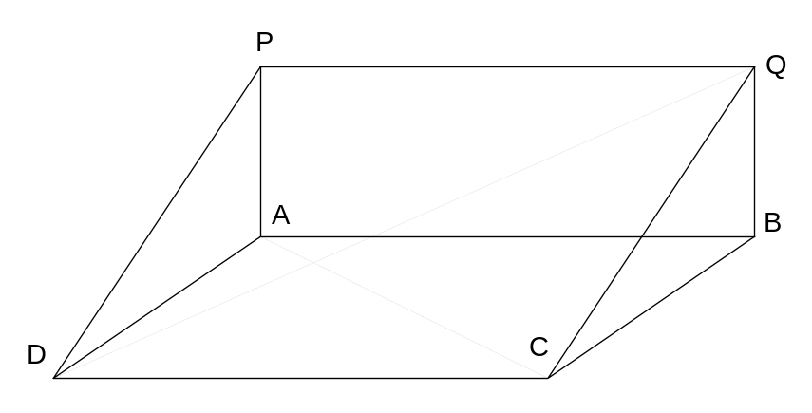
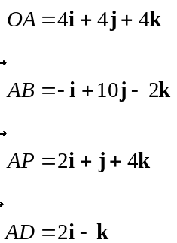

(a) Show that 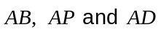 are all perpendicular to each other. (2 marks)

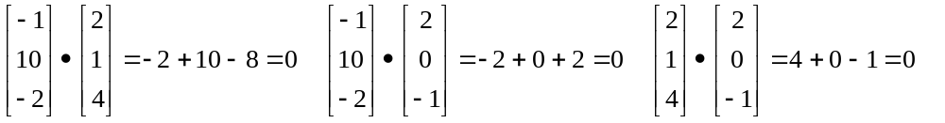

(b) Show that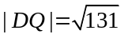. (2 marks)

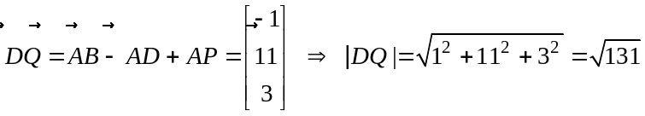

(c) At time 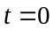 seconds, a small body, , leaves 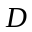 and moves directly towards Q with a constant velocity of 1.5 m/s. Write down an equation for the position vector of at any time . (3 marks)
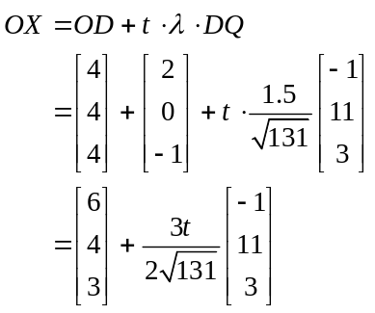

(d) At the same instant that leaves , a second small body, , leaves and moves directly towards with a constant velocity of 1 m/s. Determine the minimum distance between and during this motion, to the nearest centimetre. (7 marks)

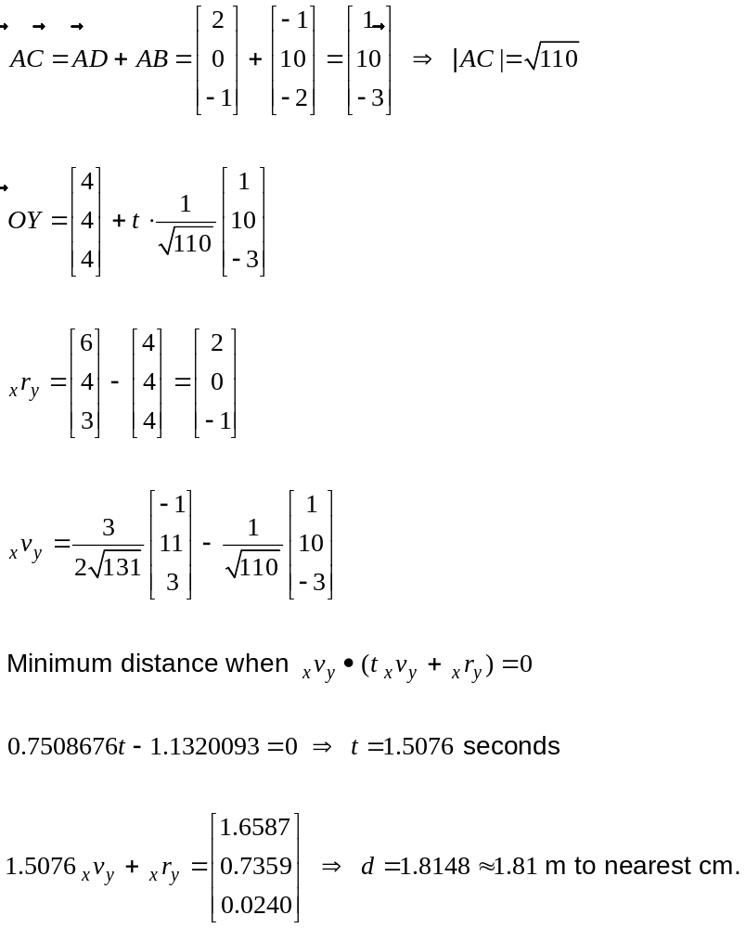

Question 20 (5 marks)
Prove that the last digit of 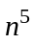, where is a positive integer, is always the last digit of .

can be written in the form 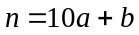, where and are both integers,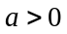 and 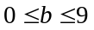.

The last digit of will be the same as the last digit of 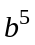 since

Since , there are 10 cases to consider:

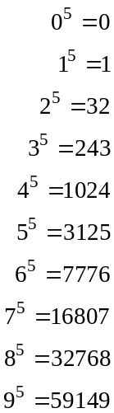

In each case, it can be seen that the last digit of is the last digit of , and so the last digit of will always be .

Additional working space

Question number: _________

This examination paper may be freely copied, or communicated on an intranet, for non-commercial purposes within educational institutes that have purchased the paper from WA Examination Papers provided that WA Examination Papers is acknowledged as the copyright owner. Teachers within Rossmoyne Senior High School may change the paper provided that WA Examination Paper's moral rights are not infringed.

Copying or communication for any other purposes can only be done within the terms of the Copyright Act or with prior written permission of WA Examination papers.

Published by WA Examination Papers
PO Box 445 Claremont WA 6910

